HW1: Mid-term assignment report

*Pedro Miguel Bastos Almeida [93150]*, v2021-05-14

Git: <https://github.com/bastos-01/TQS-AirQuality>

1 Introduction 1

1.1 Overview of the work 1

1.2 Current limitations 1

2 Product specification 1

2.1 Functional scope and supported interactions 1

2.2 System architecture 2

2.3 API for developers 2

3 Quality assurance 2

3.1 Overall strategy for testing 2

3.2 Unit and integration testing 2

3.3 Functional testing 2

3.4 Static code analysis 2

3.5 Continuous integration pipeline [optional] 3

4 References & resources 3

# Introduction

## Overview of the work

This report presents the midterm individual project required for TQS, covering both the software product features and the adopted quality assurance strategy.

The project was intended to be about air quality. It was intended to have a **REST API** that consumes and external API (in my case, [AirVisual API](https://api-docs.iqair.com/?version=latest)). It was also supposed to have tests in multiple levels. Finally, it has a basic frontend Single Page Application that allows the user to search for the weather and pollution, as well as verify the cache details of the **REST API**. The product that I built is called **AirQuality** and it allows people to select The Country, State and City and receive information not only on the Pollution metrics, but also in the weather forecast. As said before, it is also possible to see the cache details.

## Current limitations

The outside API chosen had some problems in specific cities. Unfortunately, I only found out that later, so I couldn’t afford to change it. For example, the API says that Coimbra is available, but when searching for information on that city, it fails. Because it happens in very few cities, I didn’t think that it would matter that much.

Besides that, the product has some unimplemented features:

* Second API – Although it was for extra points, I still consider that it was expected to integrate another API.
* Continuous Integration Framework – As the second API, this was also for extra points and it is not implemented.

It also should have more tests on the **CityServiceImplementation**, that I didn’t write due to lack of time.

# Product specification

## Functional scope and supported interactions

The application is pretty simple. The user needs to select the Country, State and City that he wants to search for the weather and pollution details. After clicking in the search button, the information will show. Besides that, it is possible to see the hits, misses and requests on the cache section. By clicking in the Update button, the stats will be updated.

The initial landing section is pretty simple. The user can clearly see what the application can do and by clicking in “Search Now” the page will scroll down to the search section.

The search section has 3 dropdowns to choose the Country, State and City to get the details.

After choosing the intended regions and clicking on Search, the weather forecast and pollution details will show up, as well as the latitude and longitude of its city.

As we can see, in the upper part it shows the latitude and longitude. On the Weather card, there is information about the temperature, pressure, humidity and wind speed. Finally, on the pollution card we have the AQI (Air Quality Index) on both US and China standards, followed by their main pollutants.

Scrolling down, we get to the cache section, that informs us about the hits(Cache used), misses(Cache not used, requested to the external API) and requests(total number of requests).

## Text Description automatically generatedDiagram Description automatically generatedSystem architecture

As we can see, the frontend was made with basic web technologies – HTML + CSS + JS + JQuery + AJAX.

The Bakcend was built in Spring Boot as asked, with a REST API, a service that calls the external API and the Cache implementation. Finally, the repository used was H2, with the connection made by JPA.

For better understanding of the backend, I decided to add the UML Class Diagram. The Rest controller is in the Class CityRestController, that receives the requests from the frontend and calls the appropriate methods of the service (Class CityServiceImplementation). Then, the service calls the external API (if the data is not already stored in cache). In addition, the class Swagger2Config is to have an endpoint with the documentation.

## Graphical user interface, application Description automatically generatedAPI for developers

The documentation of our API can be found in <http://localhost:8080/swagger-ui.html>.

As we can see, there are several endpoints for the developer to use. Basically, all the /list endpoints are to retrieve all available coutries/states/cities. Then there is one endpoint to get the forecast information and one to get the cache details.

* **/api/list/** (get all the countries available)
* Graphical user interface, text, application, email

  Description automatically generatedType: GET
* **/api/list/{country} (**returns the list of available states from the selected country)
* TYPE: GET

* **/api/list/{country}/{state} (**returns all the cities available from the selected state)
* Type: GET

* **/api/{country}/{state}/{city} (**returns the weather and pollution forecast)
* Graphical user interface, text, email

  Description automatically generatedType: GET
* **/api/cache** (returns the hits, misses and requests of the cache)
* Graphical user interface, text, application, email

  Description automatically generatedType: GET

# Quality assurance

## Overall strategy for testing

First, I decided to do TDD (Test Driven Development). But then I realized that the REST API and the frontend were quite simple to do. So, I decided to the skeleton of the REST API and then write the tests (Before making the API I already had the idea to most tests and wrote it on a paper).

Almost everything has tests implemented. For unit tests, I used **Junit5.** Then, for integration and service tests, **Mockito** and **SpringBoot MockMvc** was used. Finally, for functional tests on the web interface, **Selenium WebDriver** was used.

## Unit and integration testing

**Unit Tests**

Starting by the Unit tests, I decided to write tests on the classes (**City, Weather, Pollution**) just because the % of code coverage was getting lower because of those classes. These are simple asserts on automatically generated get methods:

Then, most of my Unit tests were written for the **Cache** class. I made tests to add/delete an entry, a test to verify the Thread that implements the time-to-live policy (check whether the cache cleans over time or not) and a test to verify the hits, misses and requests:

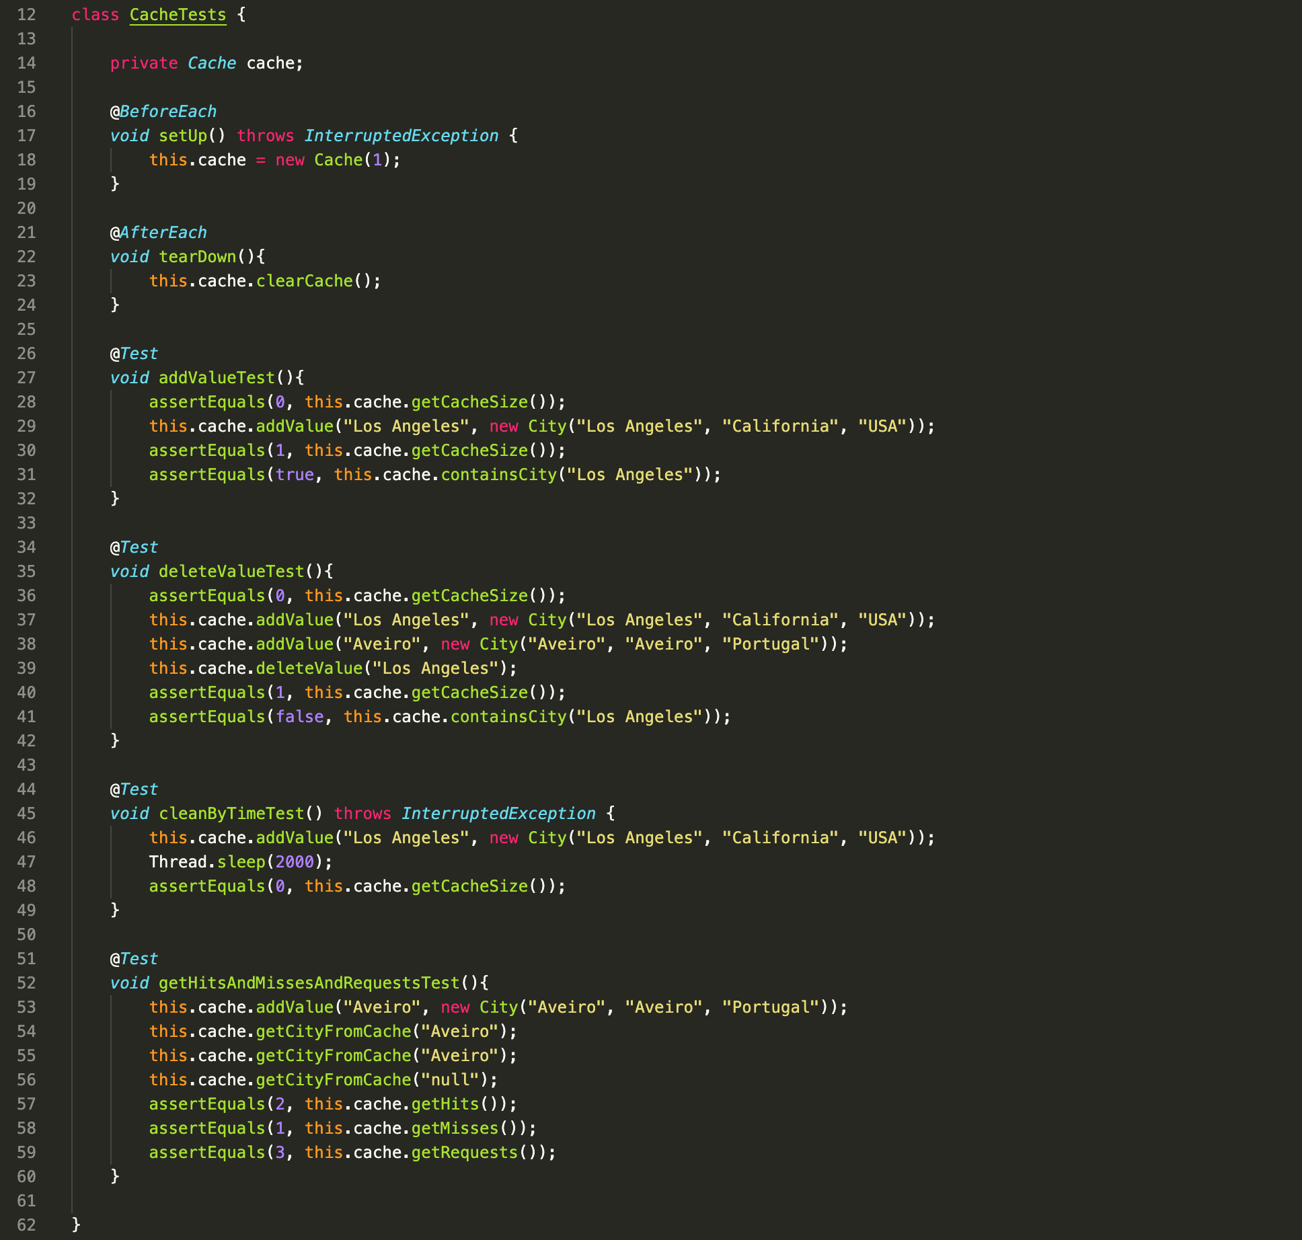

Then, some basic unit tests were made for **CityRepository**. The class **TestEntityManager** was used to make these tests possible. Also, the annotation **@DataJpaTest**. There are only 2 tests written for this class, as most of it is generated by **JPA**:

Then, I wrote **service level** tests using dependency isolation **Mocks**. As was said earlier, I should have written more tests for the service, but didn’t due to lack of time. Still, I wrote a test to the method that returns the city:

**Integration Tests**

For the integration tests, **SpringBoot MockMvc** was used. Every endpoint has a test written for it, including the cache endpoint. Basically, I wrote a given statement and prepared a response from the service. Then, performed a request to the endpoint and verified whether it succeeds or not:

## Functional testing

As I said earlier, I used the **Selenium WebDriver** to make these tests (FireFox Driver). A note that I want to add here is that I had to put a lot of sleeps in between the clicks so that the selenium could find the html items. Although most of this code is generated by de Selenium IDE extension, I had to make several changes to it in order to make it find the HTML elements. The tests made here are pretty much the interaction of the user with the webpage.

The first test, chooses a city, state and country, searches and verifies if the data is showing:

The second one, does the same but verifies if the cache values are updated when clicking the update button. It verifies if the initial number of requests is not the same as after clicking it:

## Static code analysis

For static code analysis, **SonarQube** was used. Here are the results:

Most of the code smells are the sleeps that I added between the clicks on the Selenium tests, which was explained before. Because of that, I had no choice but to keep them. The code coverage is lowered by the Swagger2Config class and by the service – as I said earlier, should have more tests in this class.

With this, I actually learned that it is better to write good code right from the beginning. This is because the first time I tested the project on SonarQube, it had failed with 111 code smells (A lot of unused imports and bad variable names). I also learned that there are some issues that sonar reports that might not be valid.

# References & resources

Project resources

* Video demo <https://www.youtube.com/watch?v=8K9fgKWcC-Y> and on repository
* Ready to use application: Although it is not deployed anywhere, there is a docker-compose.yml in the root of the repository. To run the application:

**docker-compose up –build**

The application will be running on localhost:8000, the backend on localhost:8080

Reference materials

External API used:

<https://api-docs.iqair.com/?version=latest>